**PLEASE MOVE FIXED ISSUES TO FIXED BELOW**

1. Sticky header
2. Landing page bigger?
   1. 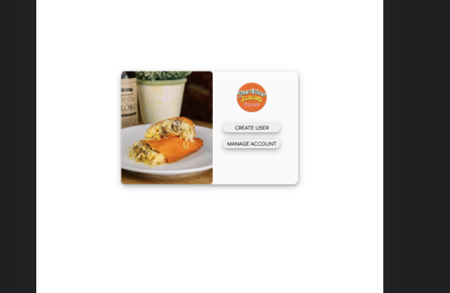
3. US4 Acceptance criteria 2, In the view franchisees list, should we see branch names or names of people? Username of co-admin and franchisee?
   1. Franchisee - input in register
   2. Co-admin - input in register
   3. Commissary - input in register

FIXED:

1. Header may parang separator pa for each button and hindi pa buttons mga nasa header, smaller screen isnt accommodated
2. Manage_account is not in the center
3. Registration is not in the center
4. Signin not in the center, sign in is not a button
5. Figma co-admin when deleted brought back to edit user
6. US 1 Acceptance criteria 5 is not met, where will admin see username and password
7. Will co-admin have the same powers as admin?
8. US 1 Acceptance criteria 6 pano si co-admin
9. US 1 Acceptance criteria 3, branch name is only for franchisees